Practical No:07
Aim: Design And Implement expression Using Demultiplexer.

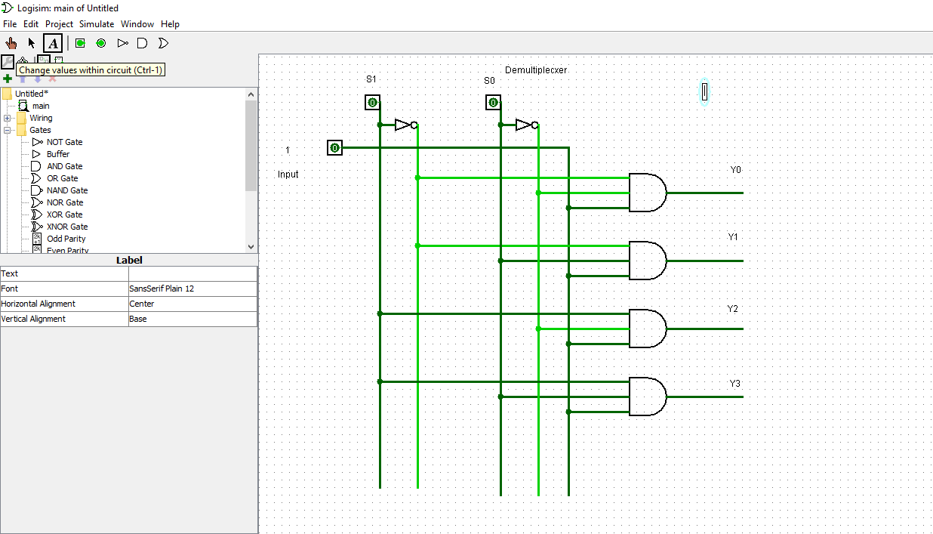

Name: Roshan dhaigude
Sub: Digital System & Architecture
Class:FYBs CS
Roll no:
Sign:

